🎤 Technical Presentation (15–20 minutes)

Topic: Cloud Computing Fundamentals

1. Introduction (1 minute)
Cloud computing has transformed the way companies build, deploy, and scale applications. Instead of relying on traditional on‑premises data centers, organizations now use cloud platforms to access computing resources on demand.

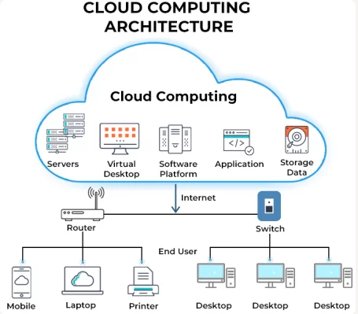
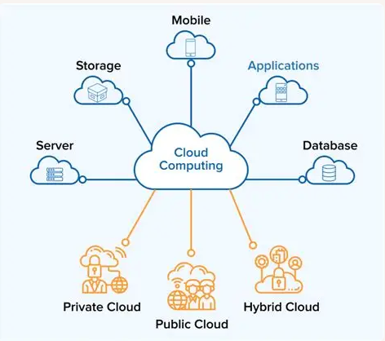
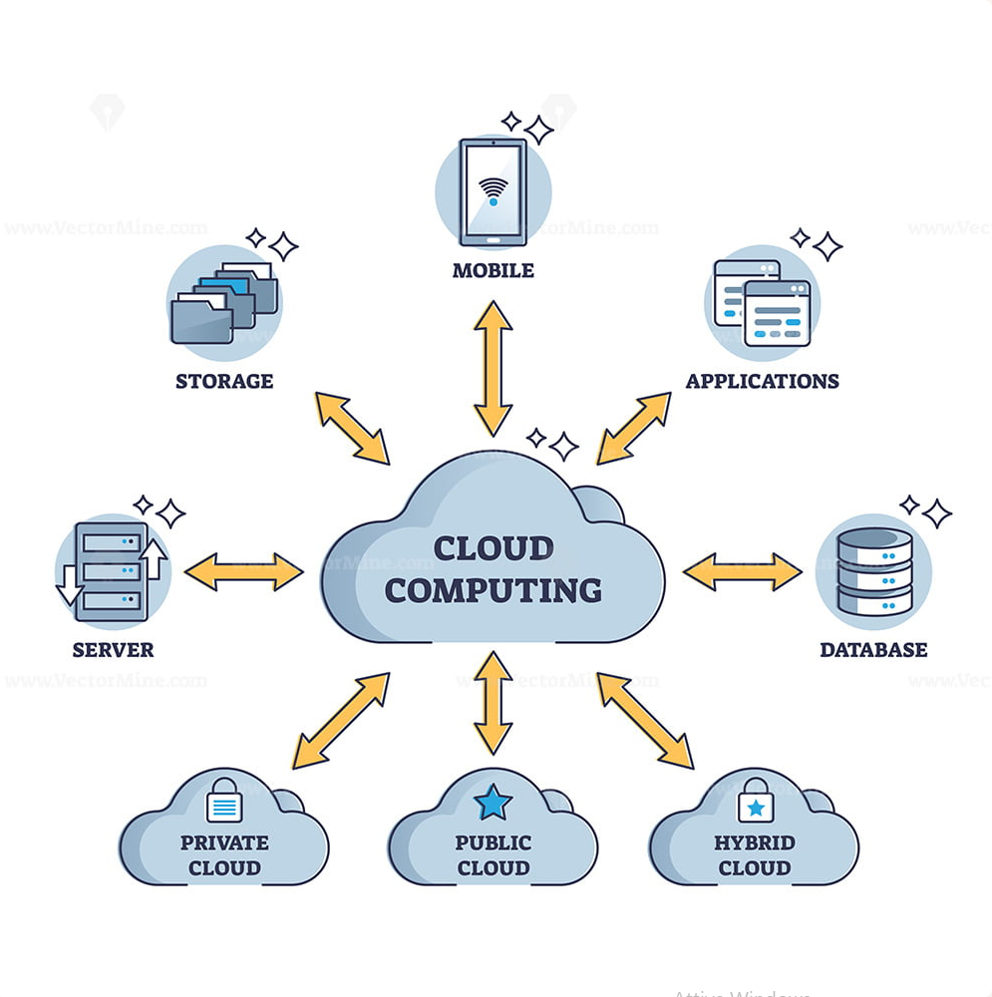
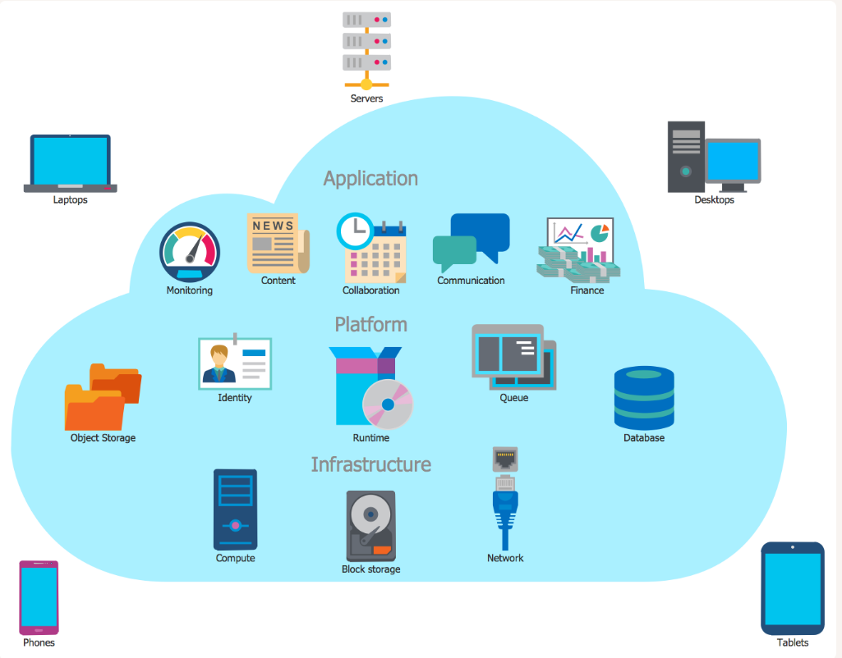

2. What is Cloud Computing? (2 minutes)
Cloud computing is the delivery of computing services—servers, storage, databases, networking, analytics, and software—over the internet (“the cloud”).

Key characteristics:
- On-demand self-service
- Scalability & elasticity
- Pay-as-you-go pricing
- Global availability
- Managed infrastructure

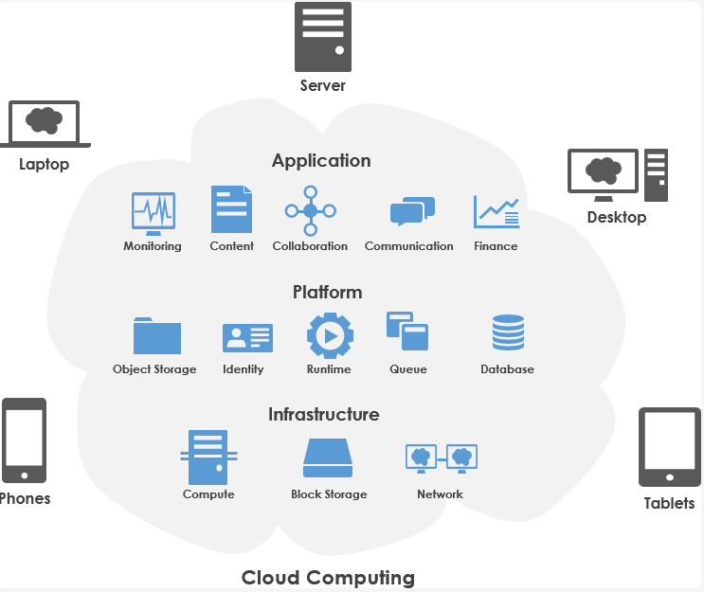

3. Evolution: From Data Centers to the Cloud (2 minutes)
Traditional data centers required:
- physical servers
- manual provisioning
- high upfront costs
- limited scalability
Cloud platforms replaced this with:
- virtualized resources
- automated provisioning
- global distribution
- near-infinite scalability
Real-world example:
Netflix migrated from physical data centers to AWS to achieve global scalability and high availability.

4. Cloud Service Models: IaaS, PaaS, SaaS (3 minutes)

IaaS — Infrastructure as a Service
Virtual machines, storage, networks.
Example: AWS EC2, Azure VMs.

PaaS — Platform as a Service
Managed runtime environments.
Example: Azure App Service, Google App Engine.

SaaS — Software as a Service
Fully managed applications.
Example: Microsoft 365, Salesforce.

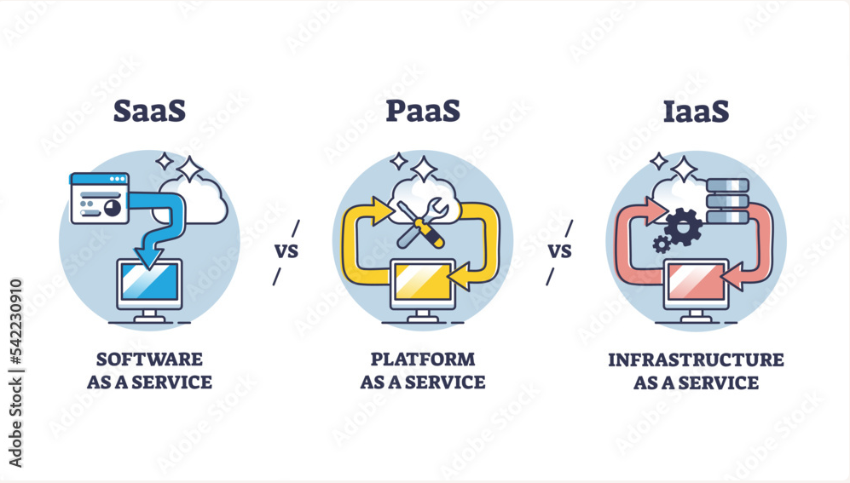
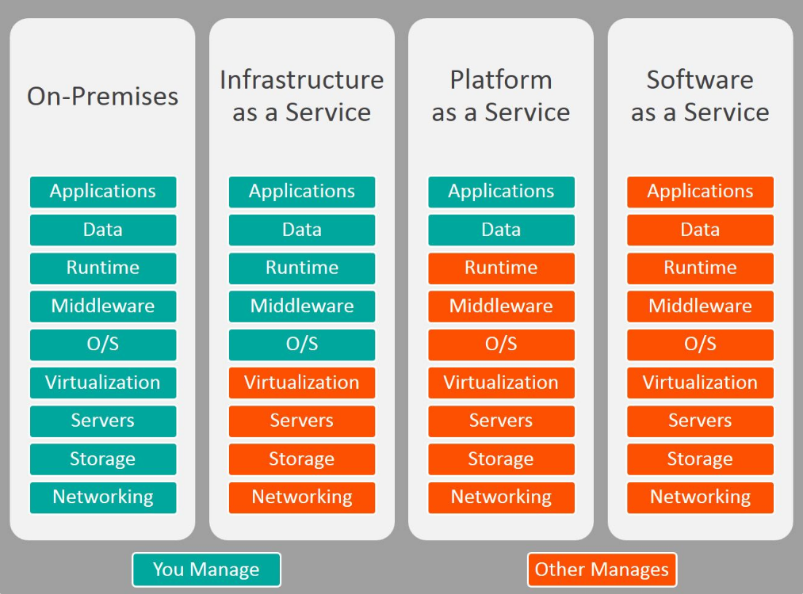
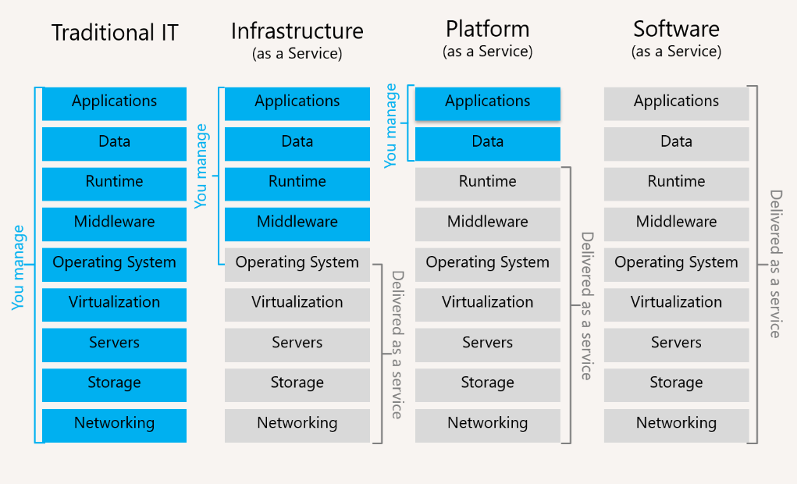
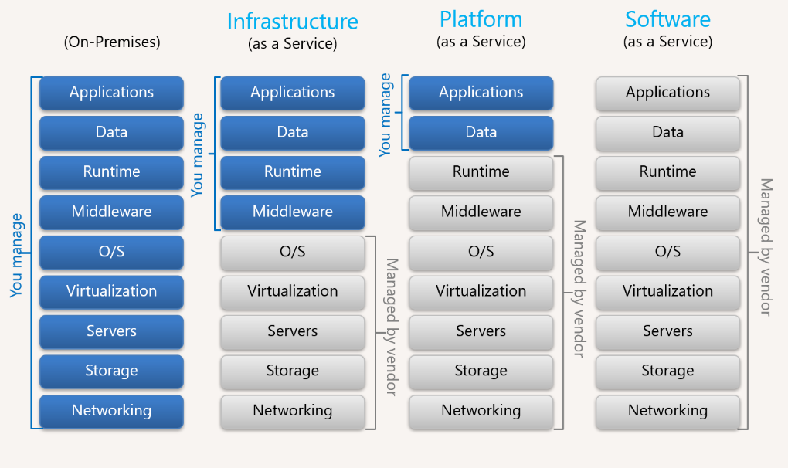

5. Cloud Deployment Models (2 minutes)

Public Cloud
Shared infrastructure (AWS, Azure, GCP).

Private Cloud
Dedicated infrastructure (VMware, OpenStack).

Hybrid Cloud
Mix of on-prem + cloud.

Multi-Cloud
Using multiple cloud providers.
Case study:
Banks often use hybrid cloud to keep sensitive data on-prem while scaling workloads in the public cloud.

6. Serverless & Cloud-Native (2 minutes)

Serverless Computing
Run code without managing servers.
Example: AWS Lambda, Azure Functions.

Cloud-Native Applications
Built using microservices, containers, CI/CD, and Kubernetes.

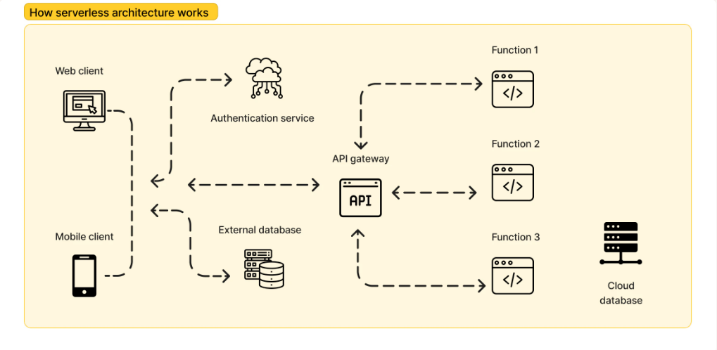
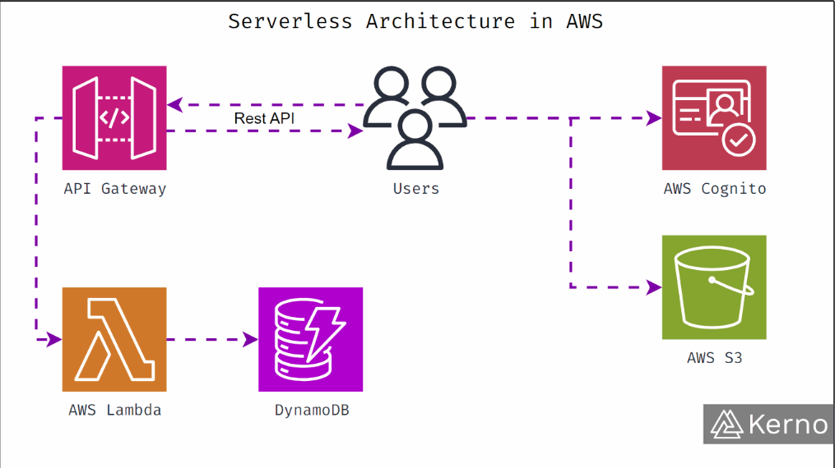
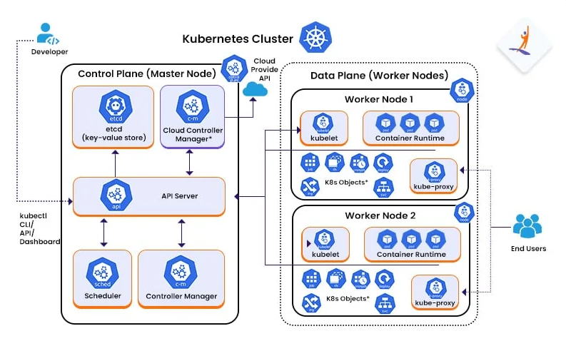

7. Edge Computing vs Cloud Computing (2 minutes)

Cloud Computing
Centralized processing in large data centers.

Edge Computing
Processing data close to the source (IoT, autonomous vehicles).
Example:
Smart cities use edge devices for traffic monitoring and cloud platforms for analytics.

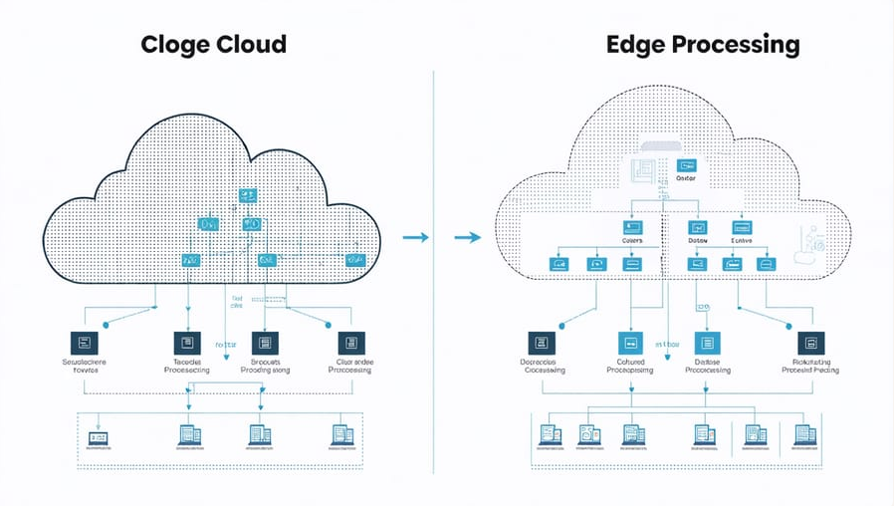
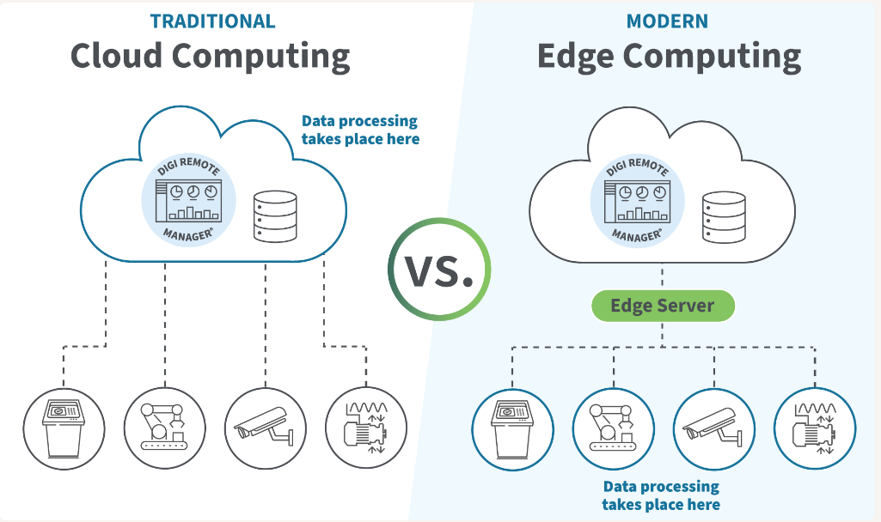

8. Real-World Case Studies (3 minutes)

Netflix
Uses AWS for global content delivery, autoscaling, and microservices.

Spotify
Uses Google Cloud for big data analytics and machine learning.

Healthcare
Cloud platforms store medical records securely and enable telemedicine.

E-commerce
Amazon and Shopify use cloud-native architectures for scalability during peak traffic.

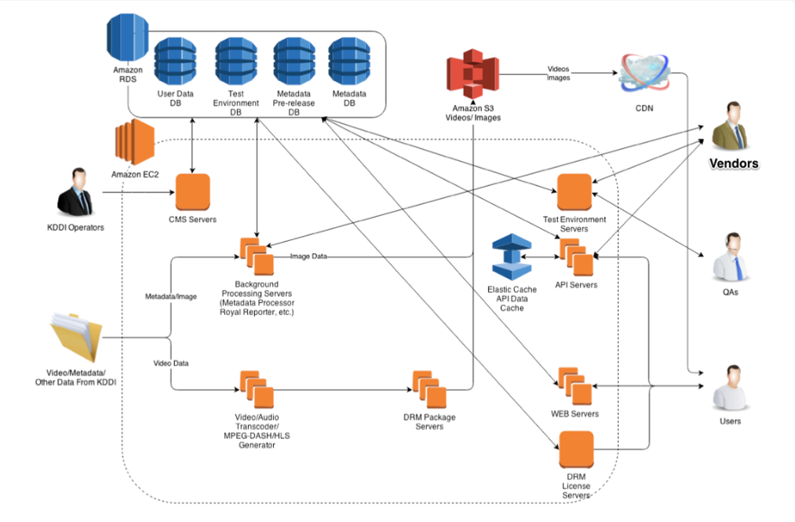
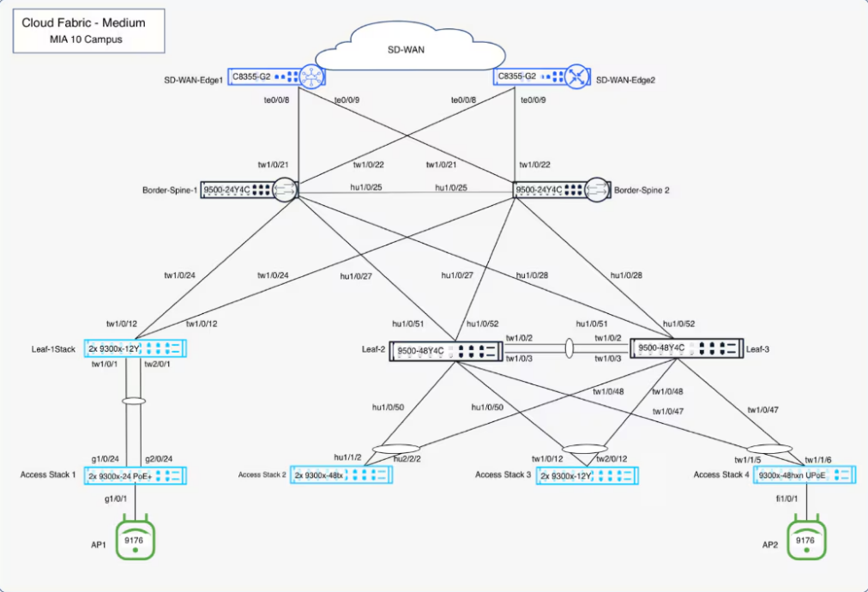

9. Summary (1 minute)
Cloud computing enables:
- flexible and scalable infrastructure
- reduced operational costs
- global availability
- rapid innovation
- modern architectures (serverless, microservices, containers)
It is now the foundation of modern IT systems across all industries.

